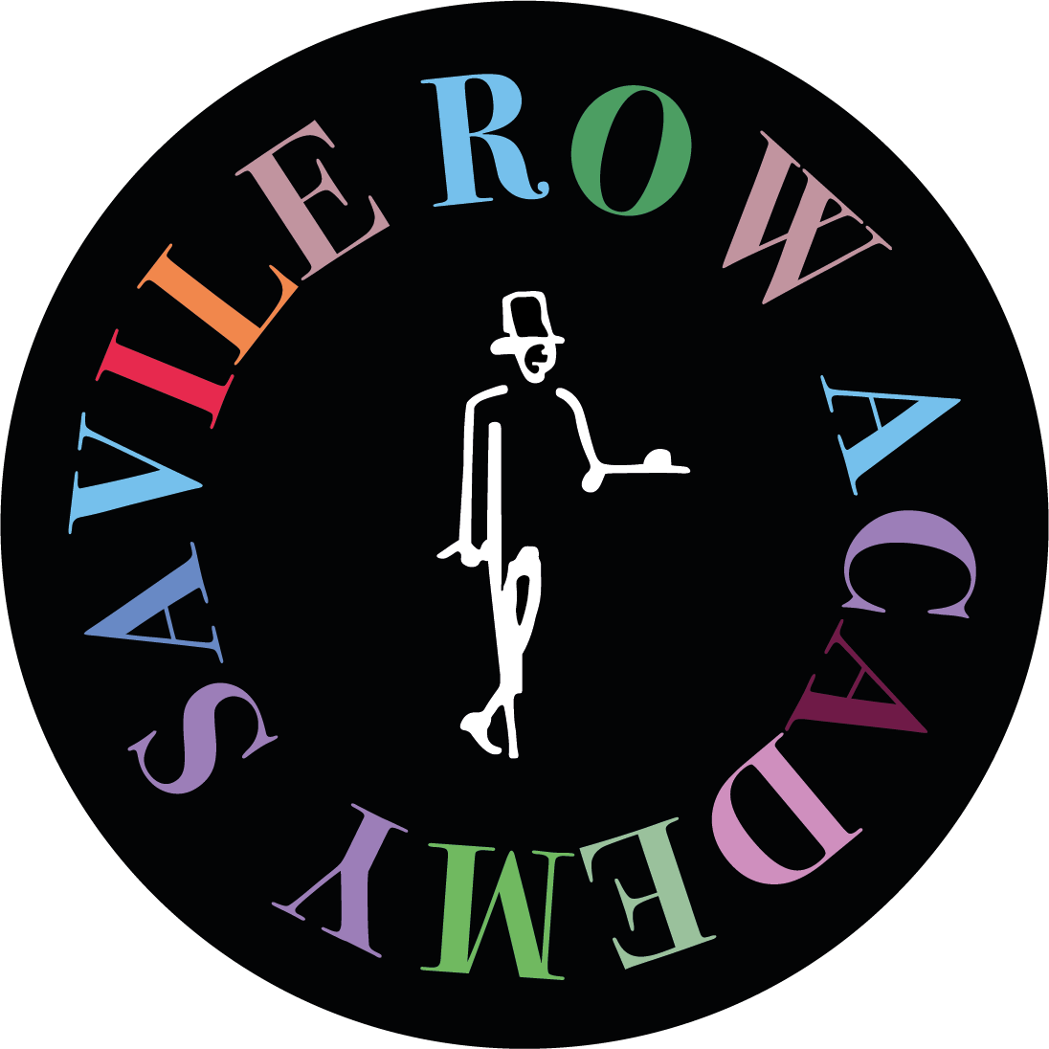

APPLICATION FORM 2024

Photo
(This is for identity confirmation - to make sure that we are interviewing the correct person in the application process.)

Certificate in Pattern Drafting, Cutting & Fitting

Please complete this form in BLOCK CAPITALS

- Personal Details
Family Name
First Name(s) in full
Gender (tick one box) | Male: |  | Female: |  | Other:
Date of Birth (dd/mm/yyyy)
Postal Address
Post Code
E-mail address
Mobile | (+ )
Country of Citizenship

Right handed : |  | Left handed :

- Educational Qualifications
Please list your educational qualifications and the awarding institution (e.g. GCSE/O Level + Grades, A Levels, Degree and any other higher level qualifications)

- Experience/ Training
Please give us details of any previous experience/training you have in the field of training

- Employment Status
Please indicate your status on the day you start the course (tick one box):

Employed: |  | Full-TIme Education: |  | Self-Employed:
Unemployed & actively seeking work: |  | Still at School: |  | Other:

Note :

- Learning Needs
This information will enable the Academy to provide learning support for you. If you prefer not to have these details recorded, please speak to the Registrar before you start the course.

Do you consider yourself disabled? (tick one box) | Yes : |  | No :

If yes, please tell why:

Do you have a specific learning need? (tick one box) | Yes : |  | No :

If yes, please provide details:

- Career Objectives
Tell us very briefly why you would like to join the Savile Row Academy and what you expect to achieve at the end of this course.

- Course Fees
If your application is successful, you will be given a provisional place on the course. Your place is reserved on your acceptance of the offer and the payment of the course fees in full. Course fees are non-refundable.

*PLEASE MAKE SURE THIS INFORMATION MATCHES WITH YOUR PASSPORT INFORMATION IF YOU ARE PLANNING TO SUBMIT A PAYMENT RECEIPT AND A CONFIRMATION LETTER FROM US TO YOUR LOCAL VISA OFFICE.

Full Name
(Same as Passport)
Postal Address
Postal Code
Mobile | (+ )

- Declaration of Student
I declare that, to the best of my knowledge, the information I have provided on this form is correct and that should my circumstances change, I will notify the Academy immediately.

Signature :

Date (dd/mm/yyyy) :

Please return completed forms to: The Registrar, Savile Row Academy, 9-10 Savile Row, 1st Floor London W1S 3PF UK or info@savilerowacademy.co.uk

